# CS 255 Business Requirements Document Template

Complete this template by replacing the bracketed text with the relevant information.

This template lays out all the different sections that you need to complete for Project One. Each section has guiding questions to prompt your thinking. These questions are meant to guide your initial responses to each area. You are encouraged to go beyond these questions using what you have learned in your readings. You will need to continually reference the interview transcript as you work to make sure that you are addressing your client’s needs. There is no required length for the final document. Instead, the goal is to complete each section based on your client’s needs.

**Tip:** You should respond in a bulleted list for each section. This will make your thoughts easier to reference when you move into the design phase for Project Two. One starter bullet has been provided for you in each section, but you will need to add more.

## System Components and Design

### Purpose

*What is the purpose of this project? Who is the client and what do they want their system to be able to do?*

* The client is DriverPass owned by Liam. Liam would like to build a system to provide driver training classes to help customers/clients pass their DMV tests (Grammarly, 2024). Liam wants the system to be able to handle online classes, practice tests, and on-road training scheduling, allowing customers to book lessons and access training materials while enabling staff to manage reservations and track students’ progress.

### System Background

*What does DriverPass want the system to do? What is the problem they want to fix? What are the different components needed for this system?*

* DriverPass wants the system to be able to reduce percentage of failed DMV tests taken by clients being able to schedule driving lessons, online classes as well as practice tests to help determine that the client is ready. DriverPass should also have a user management system in place, a way to handle reservations, different modules for learning online, and frequent DMV updates.

### Objectives and Goals

*What should this system be able to do when it is completed? What measurable tasks need to be included in the system design to achieve this?*

* When DriverPass is completed it should give users access and permissions to schedule their own driving lessons, access online training materials, take practice test, and manage their accounts (Grammarly, 2024). The tasks that should be included are booking/tracking appointments, processing payments, managing user roles, tracking progress, and maintaining DMV compliance updates.

## Requirements

### Nonfunctional Requirements

*In this section, you will detail the different nonfunctional requirements for the DriverPass system. You will need to think about the different things that the system needs to function properly.*

#### Performance Requirements

*What environments (web-based, application, etc.) does this system need to run in? How fast should the system run? How often should the system be updated?*

* This system should be web-based as noted by Ian who specified that it should “run off the web, preferably over the cloud”.
* The system should be quick and snappy as part of it will be user-facing and the user needs to have a good experience.
* The system should be updated as often as the DMV has updates, there should be a system in place to receive notifications when the DMV has updated rules or policies.

#### Platform Constraints

*What platforms (Windows, Unix, etc.) should the system run on? Does the back end require any tools, such as a database, to support this application?*

* With this being web-based we are looking more so at browsers rather than operating systems.
* Chrome, Edge, Safari, and Firefox are the popular ones that come to mind and should cover most of the client base.
* The backend should be able to store all of the users information including their progress in their DriverPass program.

#### Accuracy and Precision

*How will you distinguish between different users?* *Is the input case-sensitive? When should the system inform the admin of a problem?*

* Users can be distinguished by their accounts, each user will have their own account with their own private credentials they can use to access said account.
* Username/Email will not be case-sensitive whereas the password will be case sensitive, the password will also have certain requirements such as upper case, lower case, numbers, minimum length, and special characters.
* Admins should be informed of problems when there are bugs or if the security of the system or a user’s account is compromised.

#### Adaptability

*Can you make changes to the user (add/remove/modify) without changing code? How will the system adapt to platform updates? What type of access does the IT admin need?*

* There should be no need to change code so long as user management features are integrated into the system.
* Any updates that will happen shouldn’t require much, because this will be web-based an in the cloud, we will send the update to the server provider and they will push it into the live system.
* Ian will need access to the entire system, this way if anything is wrong Ian will already have adequate permissions to do what needs to be done.

#### Security

*What is required for the user to log in? How can you secure the connection or the data exchange between the client and the server? What should happen to the account if there is a “brute force” hacking attempt? What happens if the user forgets their password?*

* The user should have a username and password known to only them to log in.
* HTTPS should be used to ensure there is a secure connection, especially in financial cases.
* If a brute force attempt is tried there should already be some safe guard techniques in place, such as limiting login attempts and locking accounts. If there is suspicion of brute force being used, an admin and the account owner should be notified immediately.
* If a password is forgotten we should have an option to reset the password by sending a reset link to their email on file.

### Functional Requirements

*Using the information from the scenario, think about the different functions the system needs to provide. Each of your bullets should start with “The system shall . . .” For example, one functional requirement might be, “The system shall validate user credentials when logging in.”*

* The system should have different user “types” (customer, admin, it officer)
* The system should allow customers to create appointments online
* The system should track progress of assignments, classes, lessons
* The system should update upon changes to DMV rules and regulations
* The system should lock user’s out after reaching the login attempt limit
* The system should only allow future appointments

### User Interface

*What are the needs of the interface? Who are the different users for this interface? What will each user need to be able to do through the interface? How will the user interact with the interface (mobile, browser, etc.)?*

* The interface must provide a good experience
* The interface should be snappy to user input
* The interface should also be easy to navigate and not cluttered
* There will be customers, drivers, IT Officer, Secretary, Owner
* Customers should be able to book/mod/cancel their own appointments, take classes, track their progress
* Drivers should be able to view their driving schedule, communicate with customers
* IT Officer should be able to manage all users’ accounts and monitor the system (security, backend)
* Secretary should be able to book/mod/cancel appointments, take payment, matching driver to customers
* Owner should be able to check financial data, check the analytics (check where most progress is being made by customers)
* This should be accessible both on mobile and computers.
* While it is primarily built for computer use, users should not see a difference in build quality between mobile and computer.

### Assumptions

*What things were not specifically addressed in your design above? What assumptions are you making in your design about the users or the technology they have?*

* Users have minimum hardware requirements
* Users are tech savvy enough to navigate and use our system
* Development team that can produce a web-based system that works just as good on mobile
* Server used can handle clientele
* Already have a credit card vendor

### Limitations

*Any system you build will naturally have limitations. What limitations do you see in your system design? What limitations do you have as far as resources, time, budget, or technology?*

* Amount of cars, limited to 10 cars and drivers
* System minimum requirements should be based on what most users have but there will be some users lacking the hardware
* Success is the goal but it cannot be guaranteed
* Budget was not mentioned but will need enough to secure a server, website, web design, mobile friendly, all features

### Gantt Chart

*Please include a screenshot of the GANTT chart that you created with Lucidchart. Be sure to check that it meets the plan described by the characters in the interview.*

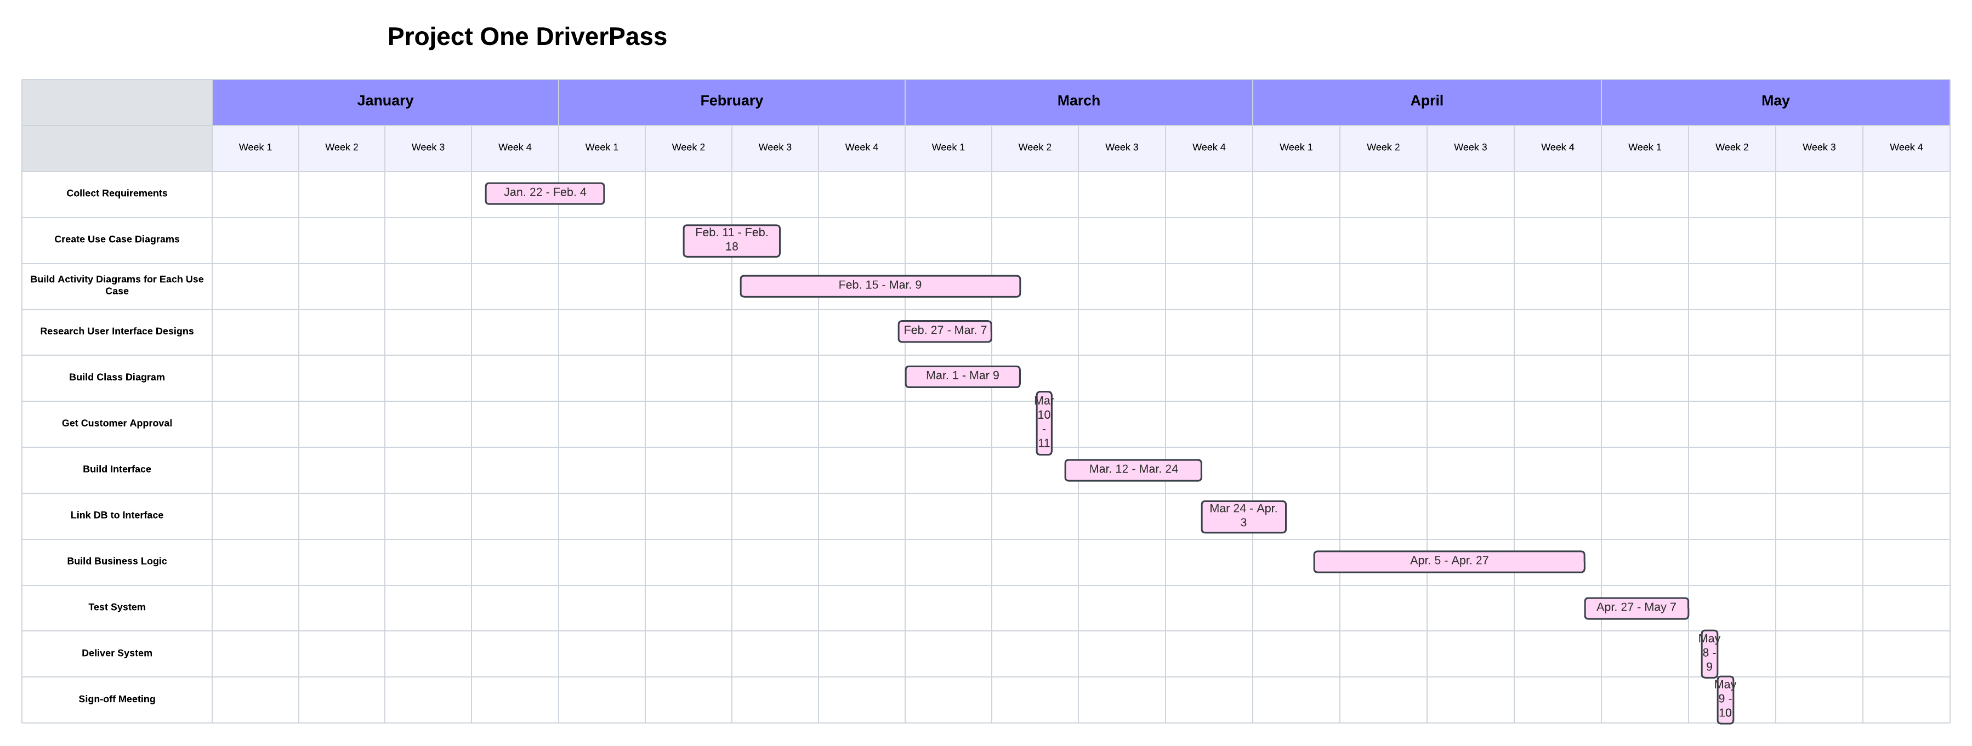

References:

Grammarly. (2024). Grammarly (Nov 10). https://www.grammarly.com/